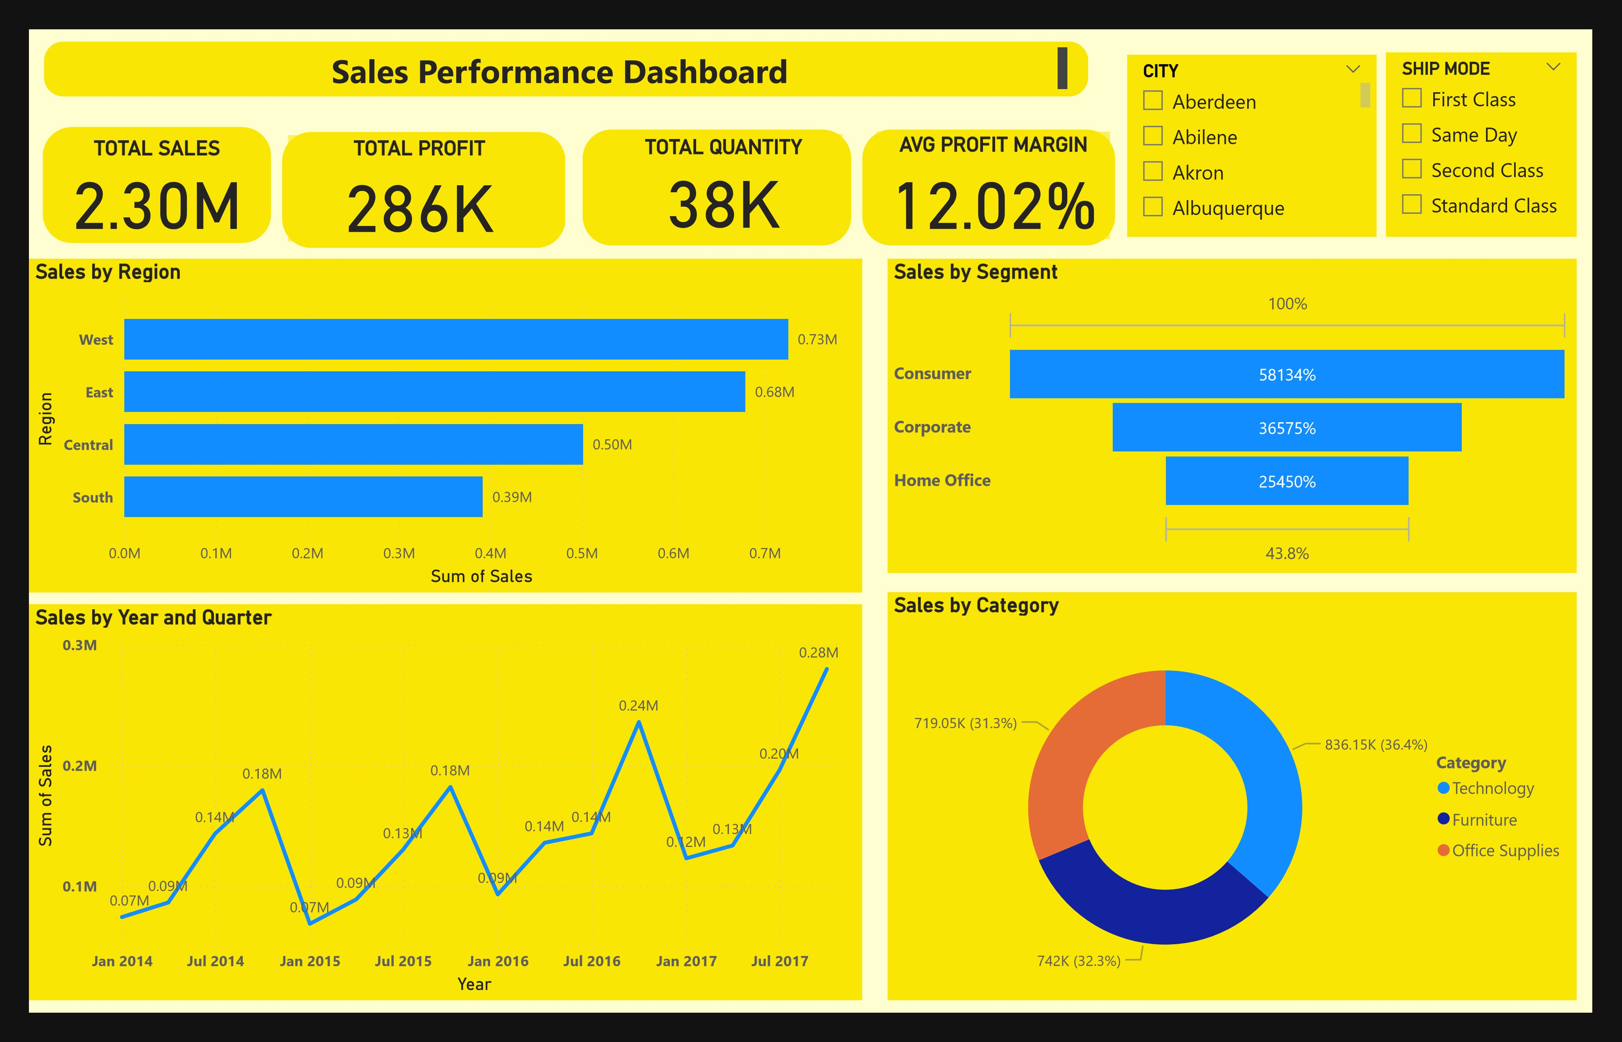

Power BI Desktop

**SALES SUMMARY**

1

.

**West Region Leads in Sales**

•

The

**West region**

outperforms all others with

**$0.73M**

in total sales.

•

It surpasses even the East region (second-highest at $0.68M), indicating stronger market performance or higher

demand in the West.

2

.

**Consumer Segment Dominates the Market**

•

The

**Consumer segment**

contributes to over

**58**

**% of total sales**

, significantly higher than Corporate (36.6%) and

Home Office (25.5%).

•

This shows the business’s major revenue stream is coming from individual consumers rather than businesses.

3

.

**Technology Category is the Top Seller**

•

**Technology**

accounts for the

**largest portion of sales**

with

**$836.15K (36.4%)**

, slightly ahead of Furniture and

Office Supplies.

•

This indicates a strong demand or focus on tech products, suggesting a potential area for expansion or

promotion.

4

.

**Seasonal Sales Peaks in Q4 2017**

•

The sales trend peaks in

**Q4 2017 (around $0.28M)**

, showing a seasonal or end-of-year sales surge.

•

This could point to holiday sales promotions or budget-year-end purchasing behavior.